**Introduction**

Thank you for your interest in joining the Data team at Streamlabs! In order to get a better understanding of your technical skills, we have compiled an assignment. This assignment gives you an opportunity to showcase your skills in a low-stress environment that closely resembles how you would normally work. In exchange for your investment of time, we commit to spending the time it takes to review your assignment at a deep level, and to give it the attention it deserves.

We believe it is important that our assessment of your skills matches the technical challenges you will face as an Analyst at Streamlabs. The assignment consists of two problems. In the first problem, you will be asked to compile SQL statements from a given schema. In the second problem, you will be asked to clean and analyze a dataset.

**Problem 1**

Consider the following Entity-Relationship Diagram:

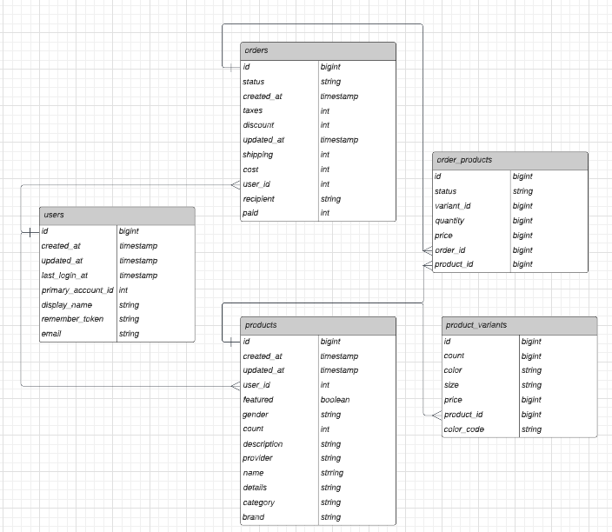

Write hypothetical SQL statements that would return the following result sets:

1. The total number of orders placed during the month of March 2022.
2. Product name, description, and category for all products ordered during the month of March 2022.
3. The top 10 best-selling products, ranked by highest count of quantity sold.
4. A list of all products ordered by any user who has purchased more than $500 in merchandise.
5. A list of all email addresses for users who ordered the “T-shirt” product in the “Red” variant.

**Problem 2**

Review the dataset “Top games on Twitch 2016-2021”, contained within the Twitch_Game_data.csv file.

After reviewing the dataset, perform the following tasks:

1. Validate the dataset. Check for errors and incompleteness and document any issues that you have discovered.
2. Analyze the data and tell us a story using visualization(s). What are some interesting observations or trends? What actions could potentially be taken, considering those observations or trends?

Remember to save and document your work, so that we can review your process and methodology.

**What We’re Looking For**

We are looking for a solid understanding of SQL fundamentals, and for a strong ability to tell a compelling story using data. The solutions to this assignment (and especially to Problem 2) are extremely open-ended. We are not looking for a specific solution/tool/software/methodology. We are looking for you to perform the requested tasks in the manner you see fit, and to be able to describe your solution(s) and the decision-making process used to find your solution(s).

**Documentation & Thought Process**

Please try to document (and comment) your code as much as you think is appropriate.

Please include a README.md file containing any instructions/details/context we should know when reviewing your submission. Please also include answers to the following questions:

* How long did it take you to complete this assignment?
* What about this assignment did you find most challenging?
* What about this assignment did you find unclear?
* Do you feel like this assignment was an appropriate level of difficulty?

**Questions**

Please email us if you have any questions along the way. We will try our best to help guide you through any ambiguity or error. Feel free to make assumptions too; Just be sure to document them as you go.

**Submission**

Please submit your completed assignment via email to your Streamlabs contact. You can submit your assignment as a zip file attachment, or, if it’s easier, you can push it to a GitHub repository and include a link to the repository. We want to thank you again for your time and for your interest in joining the data team at Streamlabs!